PENETRATION TESTING REPORT
FOOTPRINTING & NETWORK SCANNING PHASES
W2-PM-FINAL | CYBERSECURITY | NETWORKWALKS

Pentester Name  (Cybersecurity Professional) | Aawishko De
Program/Batch | B083-Networkwalks
Date | 17 September 2026
Modules completed | W2-PM1 (Multiple Kali Tools)  W2-PM5 (Zenmap Scanning)
Client/Target | 1. Networkwalks (secured written permission already)  2. My own local LAN Network
Permission secured from client? | Yes
Phases covered | Phase 1: Reconnaissance & Footprinting  Phase 2: Scanning & Network Discovery  Phase 3-5: In Progress

1. Liability Disclaimer
I carried out these activities strictly on systems I own or had explicit written permission to test. Everything shared here is strictly for educational and research purposes—do not use it to break the law. Neither I, the authors, nor Networkwalks accept any liability for how you use this information; you are fully responsible for your own actions. Misusing this material can result in criminal charges, steep fines, job loss, and a permanent record. Remember, unauthorized access is illegal in most countries, even if you cause no damage.

2. Introduction
This report covers footprinting the networkwalks.com domain using multiple Kali Linux tools (W2-PM1) and scanning my own local network with Zenmap (W2-PM5). One module covers the footprinting phase and the other covers the scanning phase, so together they show how an attacker moves from gathering public information to mapping live hosts on a network. It is the Week 2 part of my ongoing internship program at Networkwalks.
All commands were run in Kali Linux (footprinting) and on the same Kali linux with Zenmap installed (scanning). Every step below includes the exact command used, the result I observed, a screenshot as evidence, and a short note on why the finding matters from an attacker's point of view.

3. Tools Used
The table below lists each tool used in this report and its purpose.
Tool | Purpose
Kali Linux | Operating systems used for reconnaissance activities
WHOIS | Find domain registration details (owner, dates, name servers).
whatweb | Fingerprint web technologies (server, CMS, plugins, IP).
nslookup | Resolve the domain name to its IP address using DNS.
curl -I | Read the HTTP response headers of the website.
wafw00f | Detect whether a Web Application Firewall protects the site.
dnsrecon | Enumerate all DNS records (NS, MX, SPF, TXT, SRV).
Zenmap (Nmap GUI) | Scan the local subnet to find live hosts, IPs and MAC addresses.
Kali CMD(ifconfig) | Local IP and MAC address identification

4. Activities Performed

4.1 Footprinting & Reconnaissance
I performed reconnaissance against the networkwalks.com domain using six Kali Linux tools: WHOIS, WhatWeb, Nslookup, Curl, Wafw00f, and DNSRecon. Each tool was used to gather a specific category of information about the target.

First, I used WHOIS to retrieve public domain registration details and pinpoint the primary name servers. The results revealed core information regarding the domain's registration and hosting infrastructure.

Next, I used WhatWeb to discover the underlying technologies running the site. The findings highlighted WordPress 7.0.4 and WP Download Manager 3.3.58, alongside other data exposed by the web server.

Using Nslookup, I resolved the domain name directly to its main IP address, which returned 192.232.216.135.

I then ran Curl with the -I flag to analyze the HTTP response headers. This offered deeper insight into the web application, exposing the active WordPress REST API endpoint at /wp-json/.

Afterward, I deployed Wafw00f to test whether a Web Application Firewall guarded the site. The test confirmed the presence of ModSecurity (SpiderLabs).

Finally, I ran DNSRecon to enumerate all accessible DNS records. The output mapped out name servers, mail servers, SPF/TXT records, service entries, and DNS software information.

4.2 Network Scanning with Zenmap
For the second activity, I used Zenmap to perform network discovery on my local network. The practical required me to identify my local IP address and subnet, discover live hosts, identify their IP and MAC addresses, and generate a network topology.
I first used the kali Linux ifconfig command to identify my local IP address and LAN subnet. I then entered the subnet into Zenmap and selected Ping Scan to identify active hosts.
The example results provided in the practical identified three live hosts:
- 10.0.2.2
- 10.0.2.3
- 10.0.2.15
The example results also included two MAC addresses.
After completing the scan, I opened the Topology section in Zenmap, enabled the legend and saved the network topology in PDF format as required by the practical task.

5. Risk Analysis / Impact
Based on the information collected during the footprinting and network scanning activities, I identified the following potential risks.
# | Risk / Finding | Evidence / Observation | Potential Impact | Risk Level
1 | Web technology information exposed | WhatWeb identified WordPress and WP Download Manager | Attackers can exploit detailed technology version data to pinpoint software needing targeted vulnerability inspection. | ● Medium
2 | Server IP address identifiable | Nslookup resolved the domain to 192.232.216.135 | Provides information about the network location of the web service | ● Low
3 | HTTP technical information exposed | Curl returned HTTP response headers and exposed /wp-json/ | May assist technology fingerprinting and further enumeration | ● Low
4 | WAF technology identifiable | Wafw00f identified ModSecurity (SpiderLabs) | Reveals information about the web application’s security architecture | ● Low
5 | DNS infrastructure information exposed | DNSRecon identified DNS, mail and service-related records | DNS information can help build a broader infrastructure profile | ● Medium
6 | Multiple live hosts visible on local network | Zenmap identified four live hosts in the example network | Unidentified or rogue hardware could secretly exist inside a network | ● Medium

Risk level key: ● Critical ● Medium ● Low
The risks above are observations from the footprinting and scanning exercises, not confirmed vulnerabilities.
The practical exercises primarily involved information gathering and host discovery. No exploitation or vulnerability validation was performed as part of these two modules.
Therefore, the presence of information such as a software version, IP address or DNS record does not by itself mean that the system is vulnerable. Further authorized security testing would be required to confirm any actual vulnerability.

6. Recommendations
Based on the observations from these activities, I recommend the following security improvements:
- Audit public tech data
Organizations need to continually check which details regarding web frameworks, CMSs, and extensions are exposed online.

- Update software routinely
CMS instances, plugins, and third-party software must undergo frequent updates and cross-referencing with active vulnerability feeds
- Inspect HTTP headers
HTTP server headers must undergo evaluation to verify no excessive system information gets leaked to the public.

- Audit DNS entries periodically
DNS records must be inspected regularly to guarantee that only essential entries and services remain accessible externally
- Maintain and tune WAF defenses
Ensure WAF protection (ModSecurity) stays operational and calibrated, as it currently deters automated generic threats.
- Execute routine internal network scans
Organizations need to run recurring network scans to uncover all connected live hosts across their infrastructure.

- Analyze unidentifiable hardware
Every unrecognized device detected during automated scanning requires immediate investigation and proper owner verification.

- Keep network records updated
Network architecture diagrams and inventory lists must be recorded accurately and maintained on an ongoing basis.

- Execute authorized security assessments
Scanning and active reconnaissance must strictly occur on systems and environments with prior formal permission granted.

7. Conclusion
During Week 2 of my Cybersecurity & Ethical Hacking internship, I completed practical activities covering footprinting, reconnaissance and network scanning.
In the footprinting activity, I used six Kali Linux tools to collect information about the target domain. I learned how WHOIS can provide domain information, WhatWeb can identify web technologies, Nslookup can resolve domain names, Curl can inspect HTTP headers, Wafw00f can identify a WAF, and DNSRecon can provide additional DNS information.
In the network scanning activity, I used Zenmap to identify my local network configuration and discover active hosts. I also collected IP and MAC address information and created a network topology.
The exercises showed me that information gathering is an important part of cybersecurity. Even before attempting to exploit a system, a security professional can learn a significant amount about an environment by carefully analyzing publicly available information and network responses.
I also learned that technical findings should be documented clearly. A good cybersecurity report should explain what was performed, what was discovered, what the observation means, what risk it may create, and what can be done to reduce that risk.
Finally, I learned that reconnaissance and scanning must always be performed within an authorized scope. These activities were completed as part of the assigned educational cybersecurity lab.

8. Evidences Collected

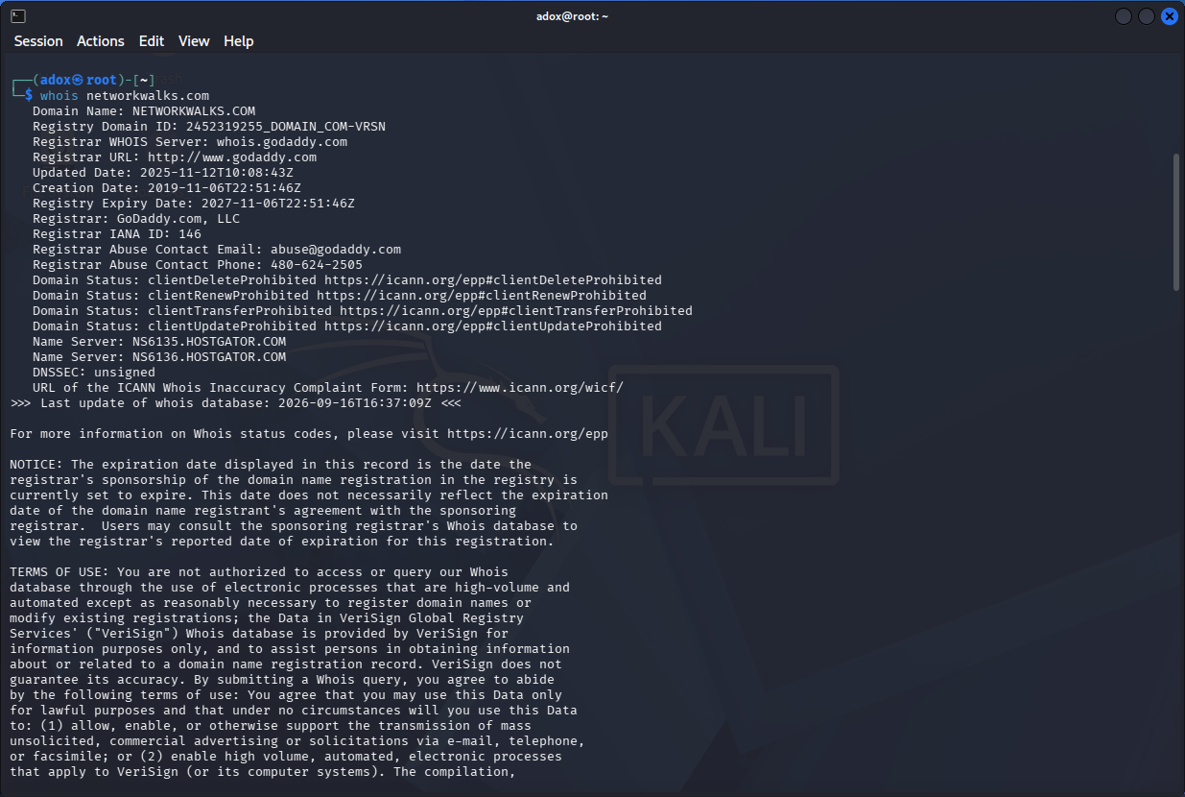

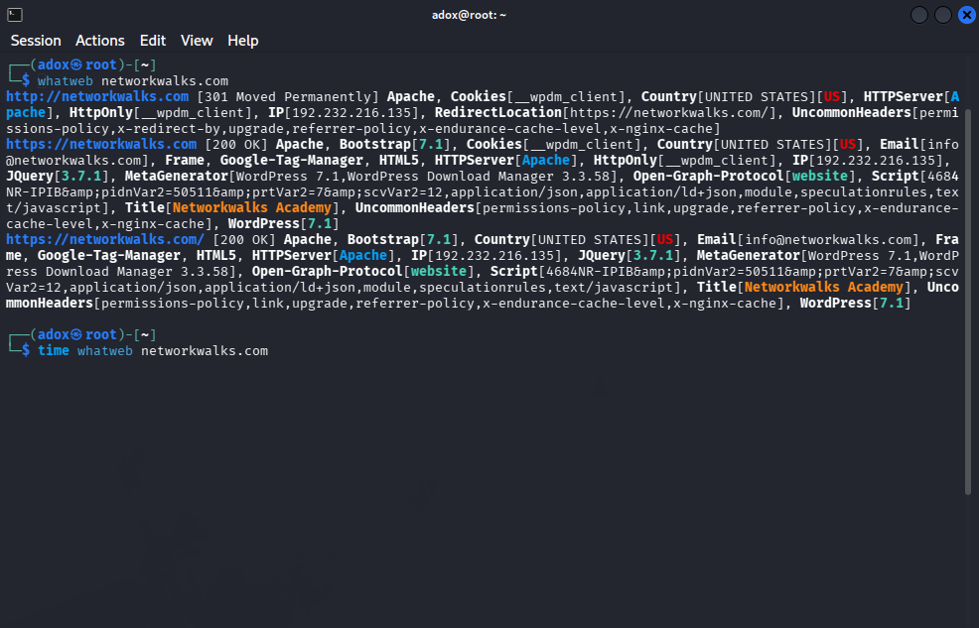

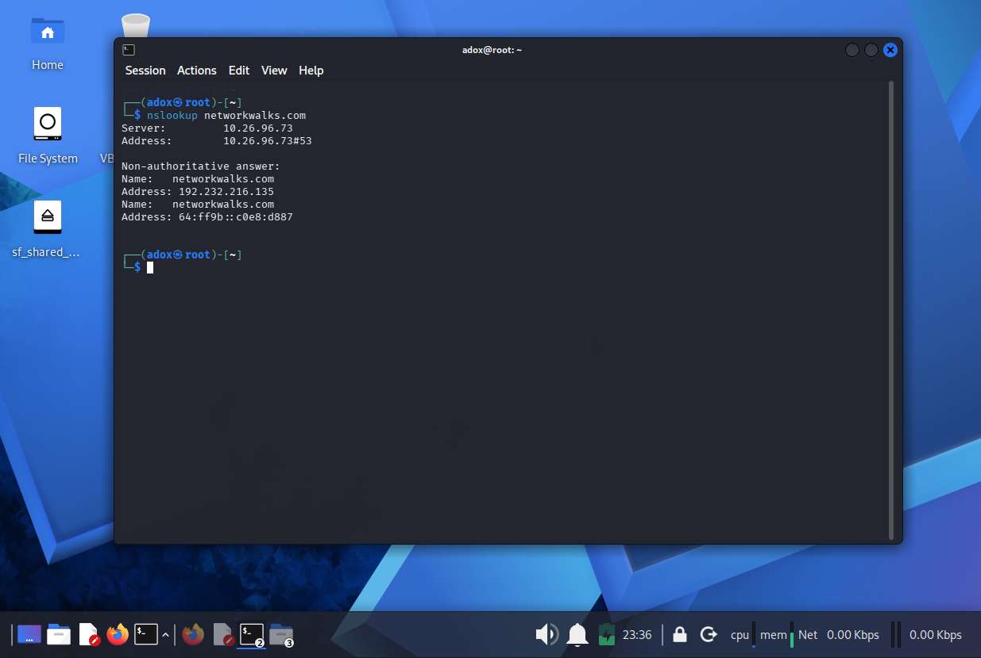

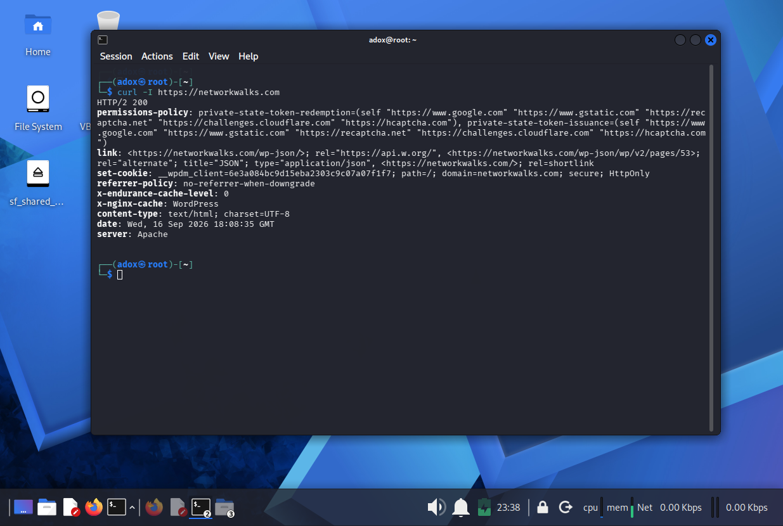

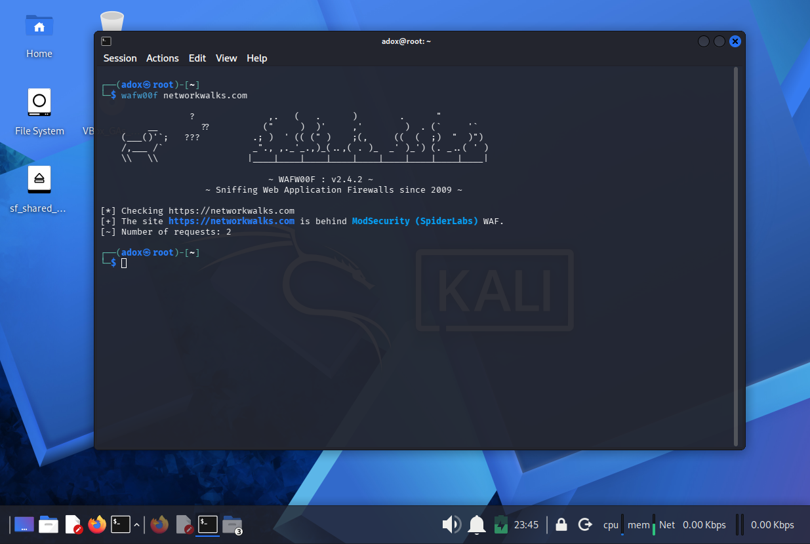
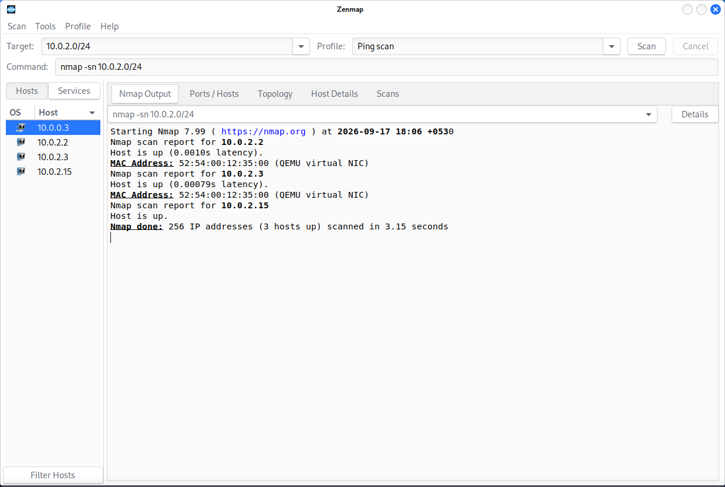

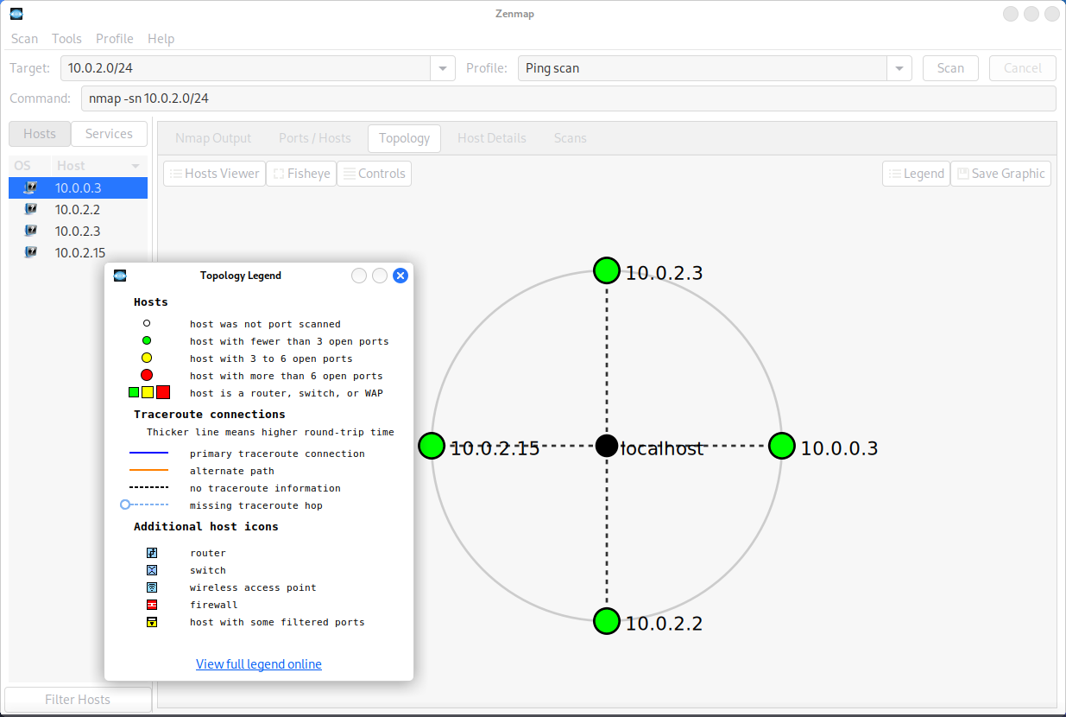

-End-

Author
Aawishko De
Cybersecurity Professional B083
LinkedIn: https://www.linkedin.com/in/aawishko-de /

📌 Project Information
Program Name: Cybersecurity program at Networkwalks | Week: 02 | Repository: GitHub

